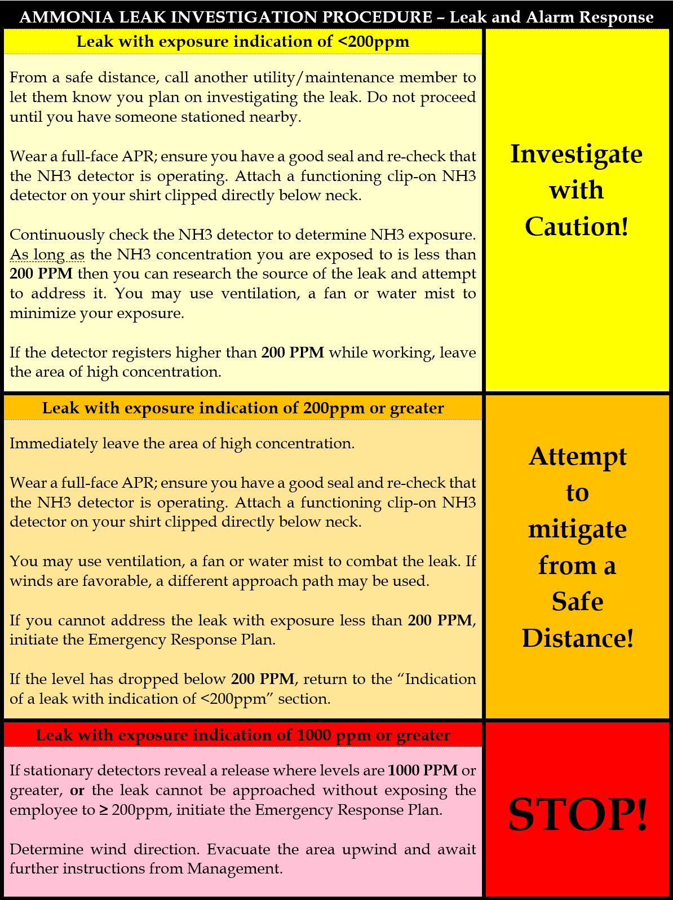
Information needed:
- When did the leak occur?
- When did the response occur?
- What, specifically, was leaking?
- What pressure it was leaking at?
- How long did it leak?
- A narrative of what happened including:
- Actions taken during your investigation
- Your exposure levels and responses to those levels.

Contact: NAME (###) ###-####
NAME (###) ###-####

